

TO BE DOCUMENT
VISA Settlement Fee Collection

PURPOSE OF THIS DOCUMENT:

- To describe the sequence of steps performed as part of the business process
- The conditions and rules of the process prior to automation
- To demonstrate how the process will work after automation
- To outline the process improvements

This document must be signed off prior to development. Once signed-off any subsequent material change to costs or scope must be managed by an appropriate change control mechanism

Owner: | Mustafa Abujazar
Author: | Farid Syed
Version: | 1.1
Date: | 26/06/2025
Status: | Draft

Document History
Date | Version | Role | Name | Organization (Dept.) | Function | Comments
26.06.2025 | 1.0 | Author | Farid Syed | OAB | Business Analyst | Created document v 1.0

Document Approval Flow
Version | Flow | Role | Name | Organization (Dept.) | Signature and Date:
1.0 | Document Prepared by | Business Analyst | Farid Syed | OAB | 26.10.2024
1.0 | Document Approved by: | Team Leader - Cards Reconciliation Specialist Card & Treasury and Investment Operations | Ali Ahmed Al Zadjali/ Zainab AlRaisi | OAB
1.0 | Document Approved by: | CoE Manager | Mustafa Abujazar | OAB

Introduction

I.1 Purpose of the document

I.2 Objectives
The process that has been selected for RPA is the “VISA Settlement Fee Collection” process conducted within the Oman Arab Bank, corporate and compliance Department.
The business objectives and benefits expected by the Business Process Owner after automation of the selected business process are:
- Better Monitoring of the overall activity by using the logs and transaction history provided by the robots.
- Scheduling the process at the specified time by the business in order to reduce the human dependency.
- Efficient reporting for better accuracy.

I.3 Process key contact
The specifications document includes concise and complete requirements of the business process and it is built based on the inputs provided by the process Subject Matter Expert (SME)/ Process Owner.
The Process Owner is expected to review it and provide signoff for accuracy and completion of the steps, context, impact and complete set of process exceptions. The names have to be included in the table below.
Role | Name | Contact details  (email, phone number) | Notes
Process SME | Ali Ahmed Al Zadjali / Mahmood Albalushi | Ali.Al-Zadjali@oman-arabbank.com / Mahmood.Al-Balushi@oman-arabbank.com | Point of contact for questions related to process details & exceptions
Process Reviewer | Ali Ahmed Al Zadjali/ Mahmood Albalushi | Ali.Al-Zadjali@oman-arabbank.com / Mahmood.Al-Balushi@oman-arabbank.com | Point of contact for questions related to process details & exceptions
Process Owner/ Approver for production | Mustafa Abujazar | Mustafa.Abujazar@oman-arabbank.com | Escalations, Delays, etc.

Process description

II.1 Process Overview
General information about the process selected for RPA prior to automation.
# | Item | Description
1 | Process full name | VISA Settlement Fee Collection
2 | Process Area | Cards Operations Department
3 | Department | Cards Operations Department
 | Process short description  (operation, activity, outcome) | Get the Visa settlement fee collection files from shared folder monthly/quarterly basis. Fetch the fee collection amount and prepare the settlement voucher  Prepare the BULKBatch posting letter in excel.  Copy and paste the transaction details to Equation mapped file  Post the bulk transaction in Equation (AS400)
 | Role(s) required for performing the process | - Shared folder access
6 | Process schedule and frequency | Schedule 1 - Monthly – 16th  Schedule 2 - Quarterly – 16th
7 | # of items processes /reference period | TBD
8 | Average handling time per item | TBD
9 | Peak period (s) | TBD
10 | Transaction Volume During Peak period | TBD
11 | Total # of FTEs supporting this activity | 1
12 | Expected increase of volume in the next reference period | N/A
13 | Level of exception rate | 0%
14 | Input data | Visa Fee Collection file as PDF & Excel - (Shared Folder)
15 | Output data | - Bulk Batch Poster letter excel file in shared folder  - Status screenshots from Equation (AS400)  - Status Email
*Add more rows to the table to include relevant data for the automation process. No fields should be left empty. Use “n/a” for the items that don`t apply to the selected business process.

II.2. Applications used in the process

The table includes a comprehensive list all the applications that are used as part of the process automated, at various steps in the flow.

# | Application name & version | System  Language | Thin/Thick  Client | Environment/  Access method | Comments
1 | MS Excel | English | Thick | Production
2 | Equation (AS400) | English | Thick | Production
3 | Outlook | English | Thick | Production
*Add more rows to the table to include the complete list of applications.

II.3 Process map

High Level Process Map:
This chapter depicts the business process at a High Level to enable developers to have a high-level understanding of the current process.

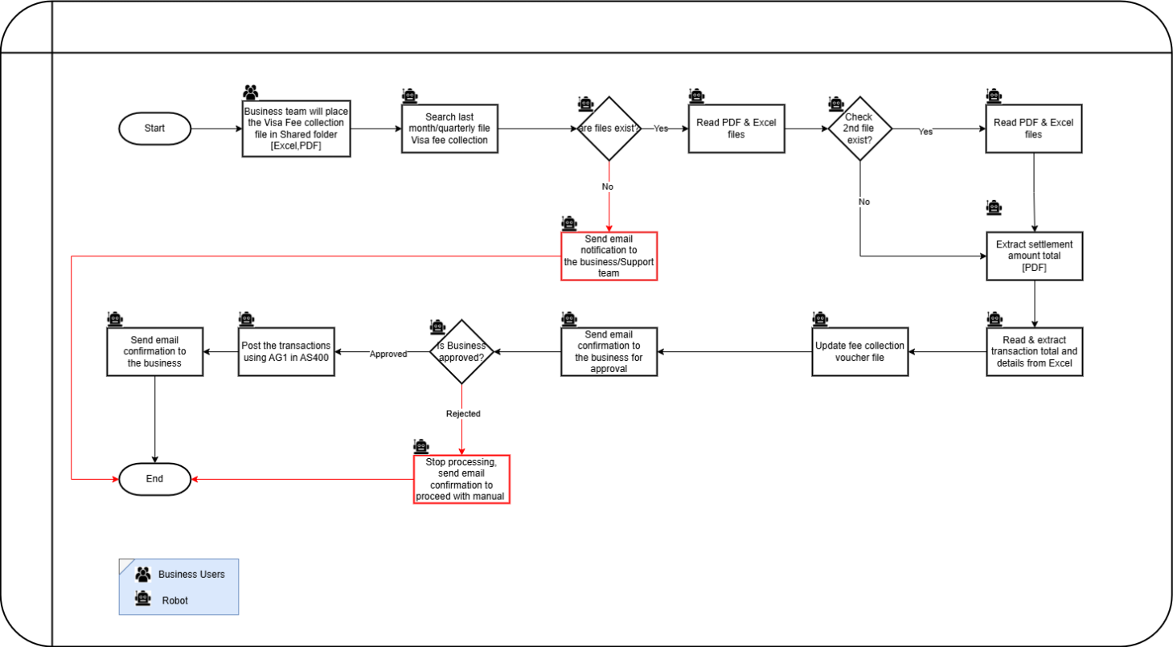

II.4 Detailed Process Steps

 | Detailed As-Is Process Steps
Step | Input | Description | Details (Screen/ Document/ Video recording Index) | Exception Handling | Possible Actions | Business Rules Library Index
See doc attached

II.4.1 Detailed TO BE Steps are
Sr.no | Steps | Description Or Screenshot
1 | Read Visa fee collection PDF file from shared folder  (TBD)
2 | Check the Fee collection type either it is Monthly or Quarterly by keywords in the file.  Monthly: ‘TOTAL BILLING THIS MONTH’ & file name should be as last month end date (30th or 31st)  Quarterly: ‘ISSUER CARD SERVICE FEE – QUARTERLY’ and file name should be between 20th to 22nd)  Note: sometime business gets 2 monthly fee collection files. If we received two monthly files than have to process each file with separate voucher. | 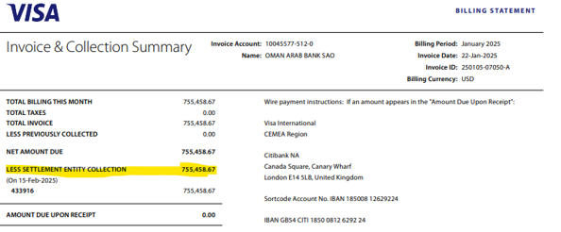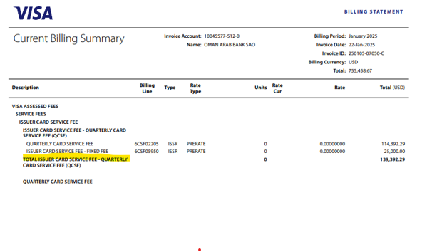
3 | If Monthly: extract ‘LESS SETTLEMENT ENTITY COLLECTION’ from PDF file. | 
4 | Open excel file, set filter on column ‘Current or Previous’ for value ‘Current Billing’
5 | Set filter on column ‘Type’ value ‘ACQR’ and take the total amount
6 | Set filter on column ‘Type’ value ‘ISSR’ and take the total amount
7 | Set filter on column ‘Type’ value ‘Both’ and take the total amount  Note: Divide the total amount of type ‘BOTH’ by 2 and add in the total of ‘ACQR’ & ‘ISSR’ in the voucher file
8 | Prepare Voucher file by converting the USD amount to OMR  (USD*0.383)
9 | Monthly Accounts:  No Debit Credit Amount Narration  BLK00AB BLK00AN BLK00AS BLK00ACT BLK00AMT BLK00NAR1  3186 931013 000 D VISA MONTHLY ASSESSMENT ISSUER  3186 990343 000 D VISA MONTHLY ASSESSMENT ACQUIRE  3186 962686 001 C VISA SETTELMENT | ¸
10 | Quarterly Accounts:  No Debit Credit Amount Narration  BLK00AB BLK00AN BLK00AS BLK00ACT BLK00AMT BLK00NAR1 BLK00NAR1  3186 931013 001 D VISA CARD QUARTERLY ASSESSMENT FEE PAID ISSR  3186 990344 000 D VISA CARD QUARTERLY ASSESSMENT FEE PAID ACQ  3186 962686 001 C VISA SETTELMENT FEE COLLECTION ACQ & ISS
11 | Final ‘Bulk Posting Letter’ excel looks like this.  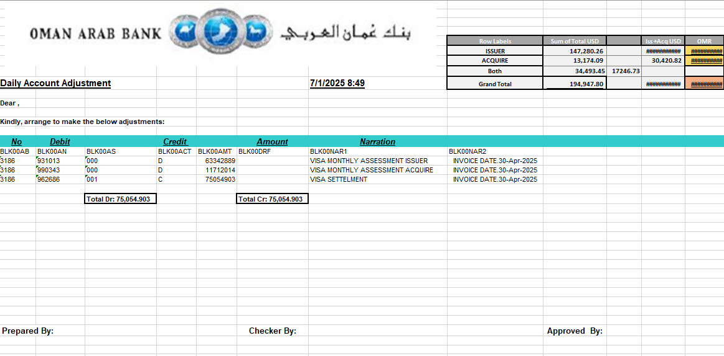
12 | Make sure Credit and Debit should have equal value.  If not equal then send email to business user.  User has to adjust the differences and update the status as ‘Approved’ in the SME approve column in the Voucher. Without changing the filename.
13 | Send email to business user for approval.  Note: User has to update the status as ‘Approved’ or ‘Rejected’ in the SME approve column in the Voucher. Without changing the filename.
14 | If user approved then, Copy transaction details from column A to Column H from voucher file  Note: if any of the value is empty or zero then remove it from transactions to avoid any file compilation issue in AS400
15 | Paste into Settlement File.xlsx  This file is use for internal to post the transactions in AS400
16 | If user Rejected then, stop the process and send email to business user to process it manually.
17 | Launch & Login to AS400 (Equation)
18 | Use option ‘AG1’
19 | Enter Account Number  As per the voucher file  Enter Amount  Press Enter
20 | Enter Currency  Enter Transaction Date  Press Shift + F12  Confirm
21 | Check the status
22 | Sign out from AS400
23 | Send email to business user

II.5 Input data description

II.6 Business Exceptions

The Business Process Owner and Business Analysts are expected to document below all the business exceptions identified in the automation process. These can be classified as:
Known | Unknown
Previously encountered. A scenario is defined with clear actions and workarounds for each case. | New situation never encountered before. It can be caused by external factors. Cannot be predicted with precision, however if it occurs, it must be communicated to an authorized person for evaluation.

Known Exceptions
The table below reflects all the business process exceptions captured during the process evaluation and documentation. These are known exceptions, met in practice before. For each of these exceptions, define a corresponding expected action that the robot should complete if it encounters the exception.
BE # | Exception name | Step | Parameters | Action to be taken
1 | File not Executed successfully |  |  | Send mail to Business team with screenshot the details and stop the bot
2 | File not available in shared folder |  |  | Send email to business team and stop the bot
3 | If total Credit and Debit not match |  |  | Send email to business team and stop the bot
4 | If business user rejected the voucher |  |  | Send email to business team and stop the bot

Unknown Exceptions
For all the other unanticipated or unknown business (process) exceptions, the robot should: Send mail to BOT controlling team

II.7 Application Error and Exception Handling
A comprehensive list of all errors, warnings or notifications should be consolidated here with the description and action to be taken, for each, by the Robot.

Known and Unknown Errors or Exceptions
The table below reflects all the errors identifiable in the process evaluation and documentation.
For each of these errors or exceptions, define a corresponding expected action that the robot should complete if it is encountered.
# | Error name | Step | Parameters | Action to be taken
1 | Any technical error while launch and login AS400 |  |  | Retry 3 times send mail to Technical team with the screenshot details. And stop the bot
2 | Unable to access shared folder |  |  | Retry 3 times send mail to Technical team with the screenshot details. And stop the bot

Other Observations
Include below any other relevant observations you consider needed to be documented here.
Example: Specific Business monitoring requirements (audit and reporting) etc.

Additional sources of process documentation
If there is additional material created to support the process automation please mention it here, along with the supported documentation provided.
Additional Process Documentation
Video Recording of the process [Optional]
Standard Operating Procedure (s)  (Optional) |  | Insert any relevant comments
Business Rules Library  (Optional) |  | Insert any relevant comments
Other documentation
(Optional)
*Add more rows to the table to reflect the complete documentation provided to support the RPA process.

